Registration page

Aim: -Here I have created a registration form which has two details to be filled email and password and we have used Mongo dB atlas in which we can see the data filled in the form by the user. The email and password are checked for validation.

Tech stack used: -

-JavaScript -Express -HTML -CSS -Mongo dB Atlas

Procedure: -

1. Here I have used atom text editor to create and edit the files.

2. I created server.js app that starts a server and listens on port 3000 for connections.

3. Then I created a form using HTML, CSS and JavaScript.

4. HTML and CSS for layout and JavaScript for validation function which checks whether email and password are according to the required constraints. Email and password are checked when we click submit button.

5. Then I fetched the data from the form using server.js and data gets stored to Mongo dB atlas. There is a procedure to connect database to app which I have done already.

3. Then I pushed the code to GitHub using terminal commands.

Below there is more description:

We have used atom text editor to code.

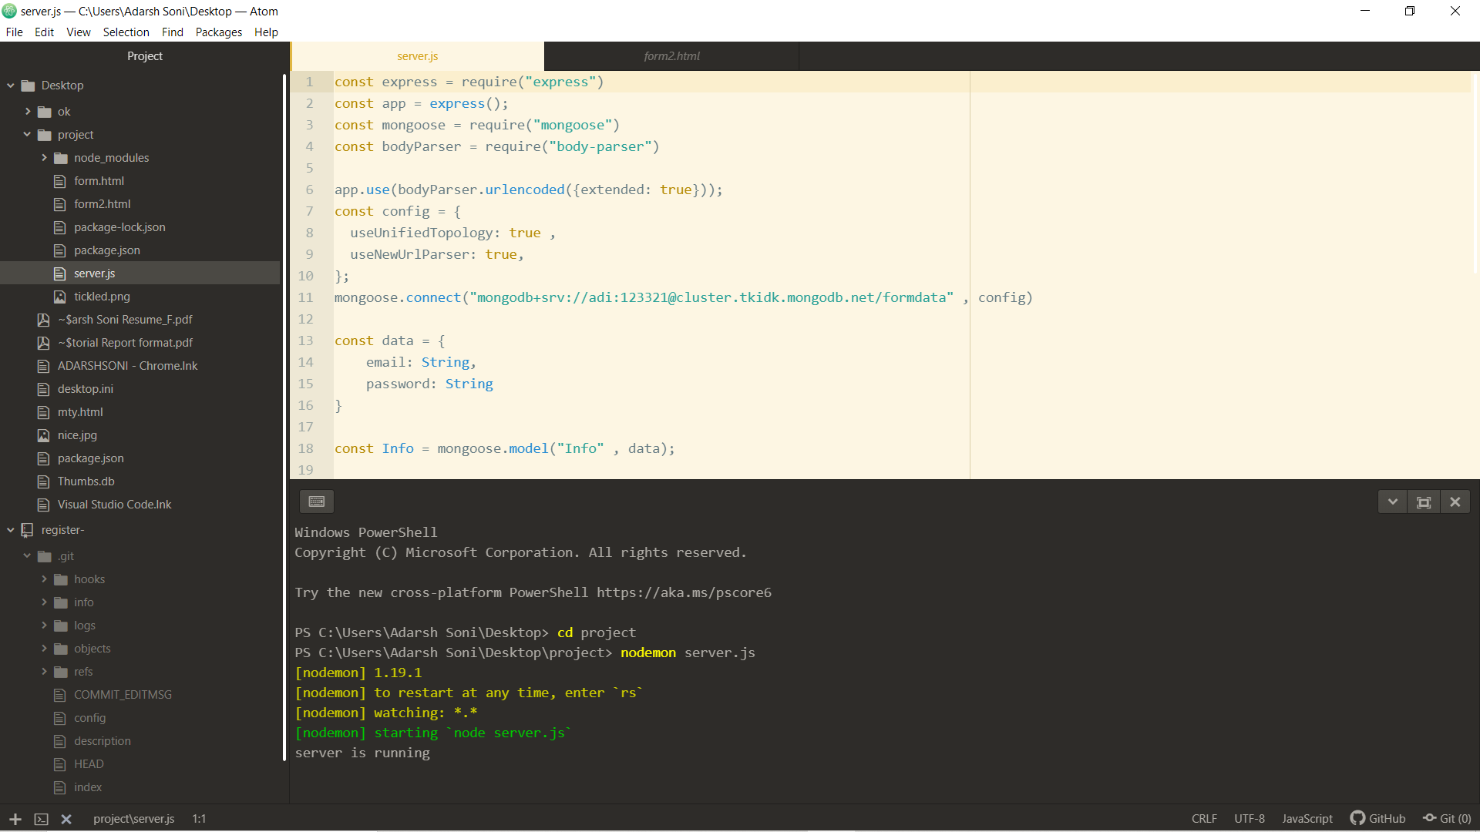

Here is our form

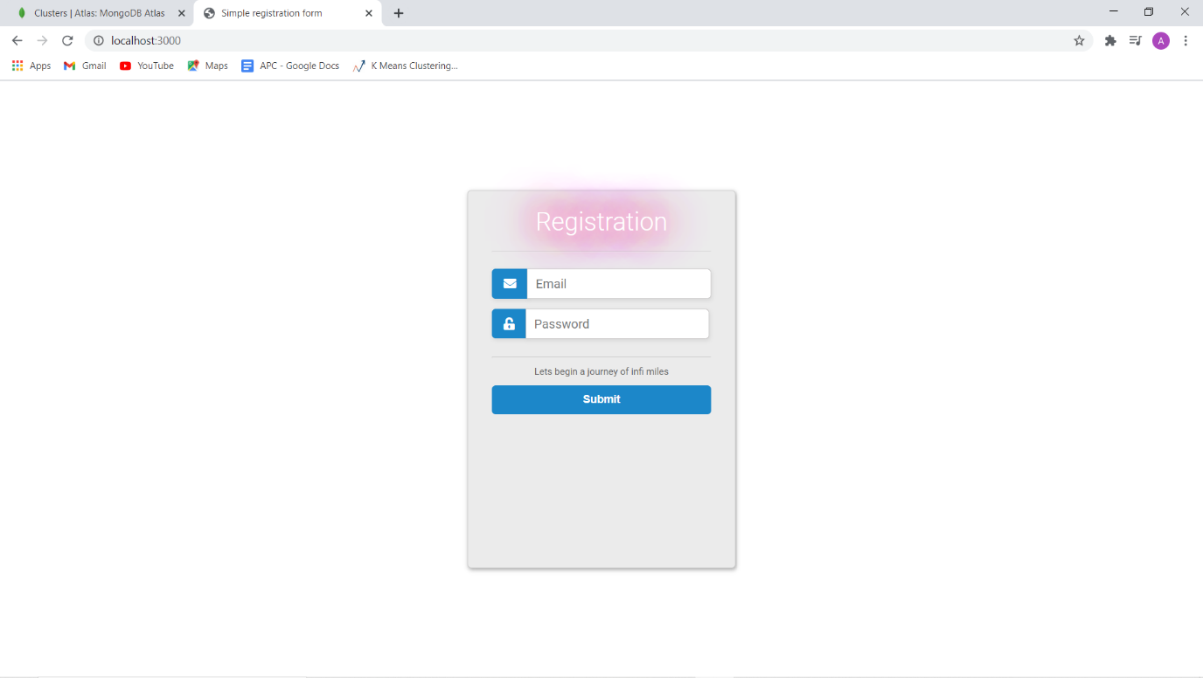

It raises error if mail is wrong.

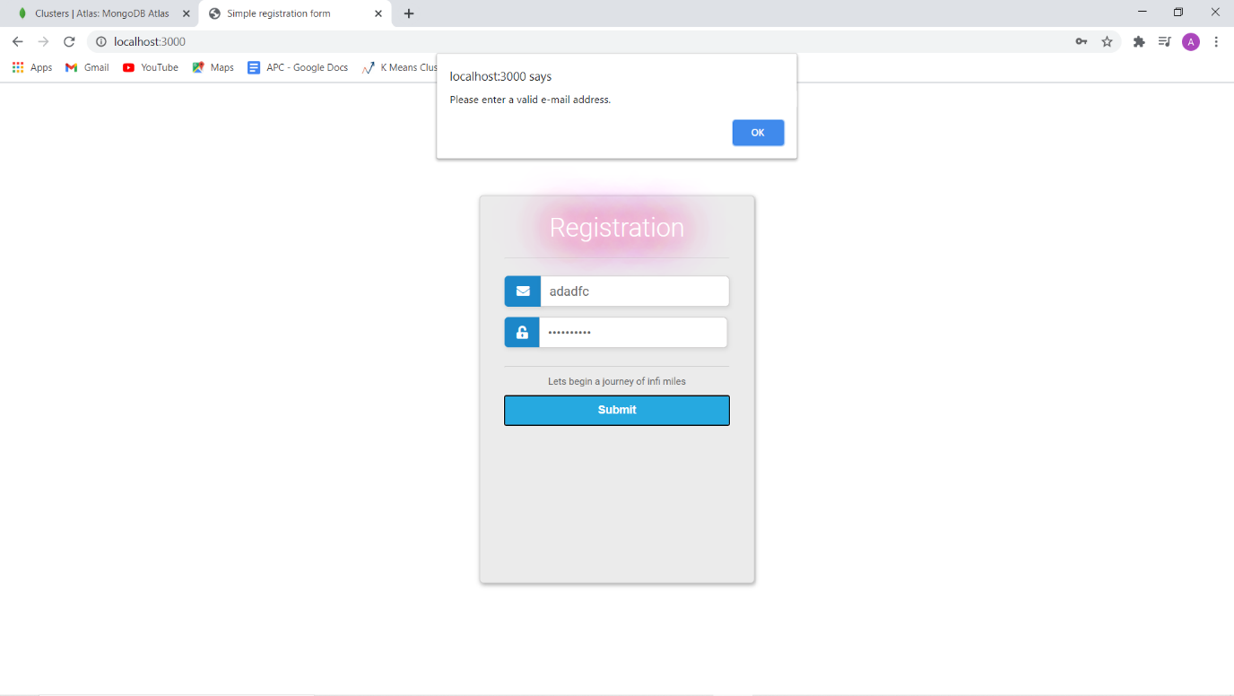

It raises error if password is wrong.

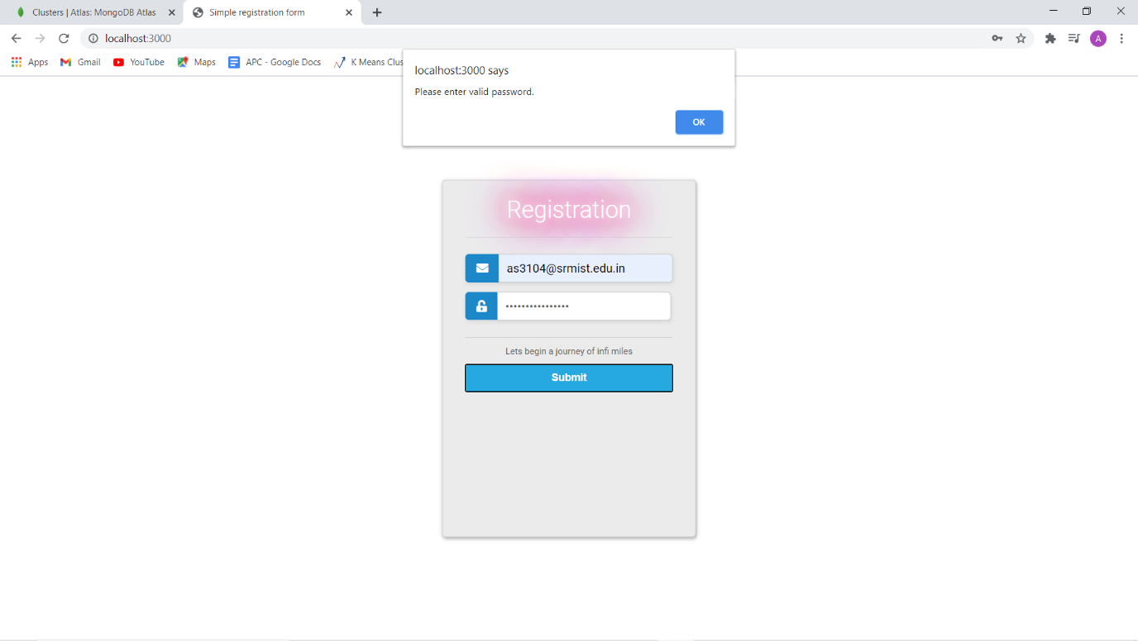

Now we can see the details entered in form got stored in our Mongo dB atlas

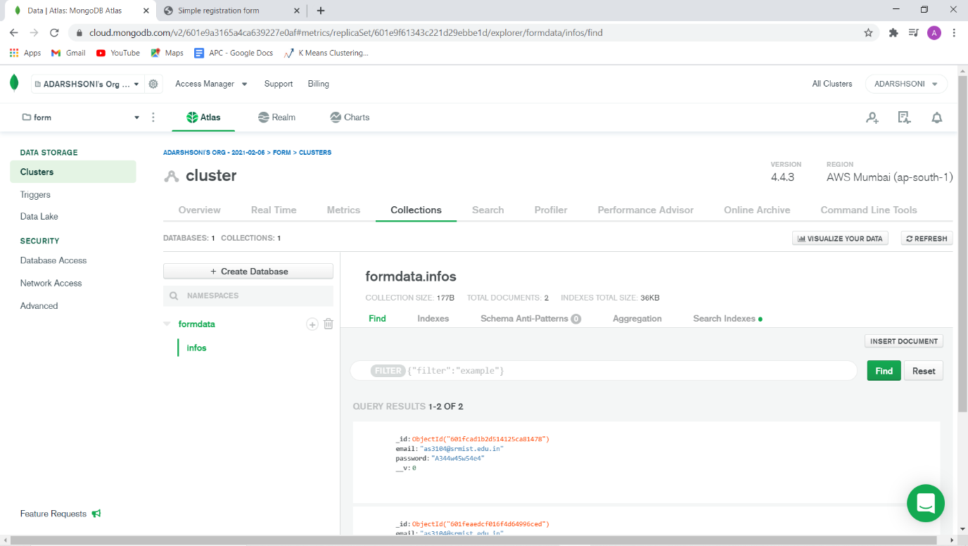

That’s all about this project. For code, please refer to GitHub. Thanks